**AWS ASSIGNMENTS**

**Q1)** Launch t2.micro instance and install httpd server on it with custom html page saying “Welcome to my page” using user data script. Access the same on your browser.

**Q2)** a) Launch another t2.micro instance and host the following website on it

<https://github.com/arvind37/Basic-Website-using-HTML-CSS> .

b) Create a network load balancer to distribute traffic between the instance created

in Q1) and Q2).

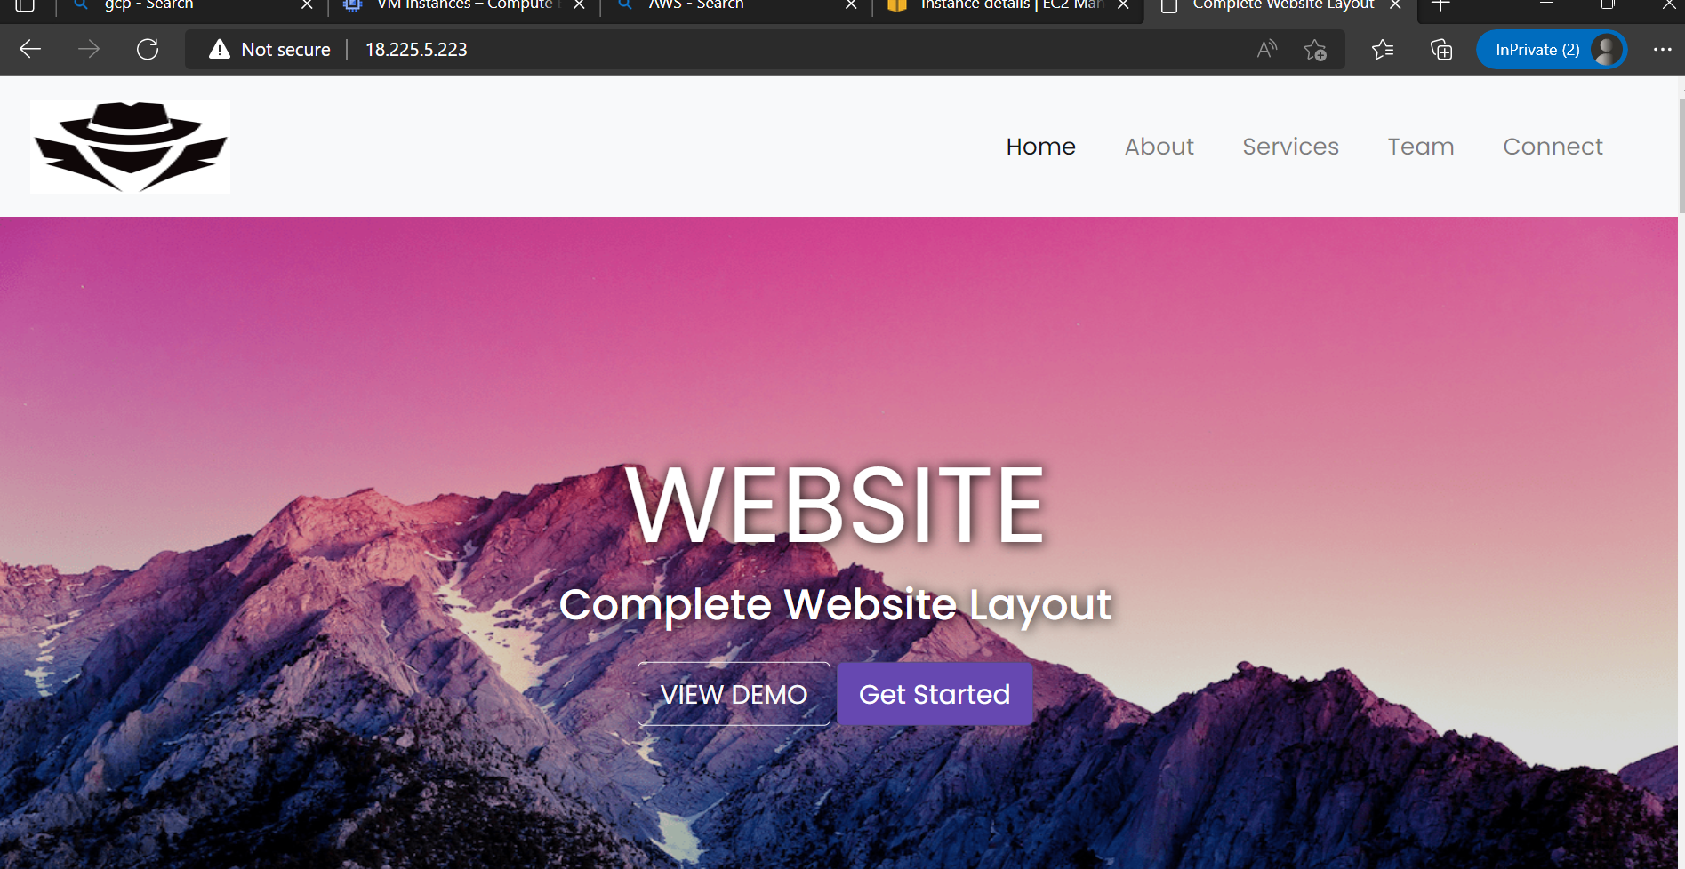

**Q3)** Create an EFS and mount on it to both the above created instances, create a file in one instance with some data which would be viewable on the other instance.

**Q4)** a). Create an s3 bucket with naming convention <your_name>_hu_devops_bucket,

upload some files into. Now from your ec2 machine(Created in Q1 or Q2) list

contents of the bucket

b). Now create a lambda function such that when you delete the file in the bucket it

trigger the function and displays “The file is deleted message” in the cloudwatch logs.

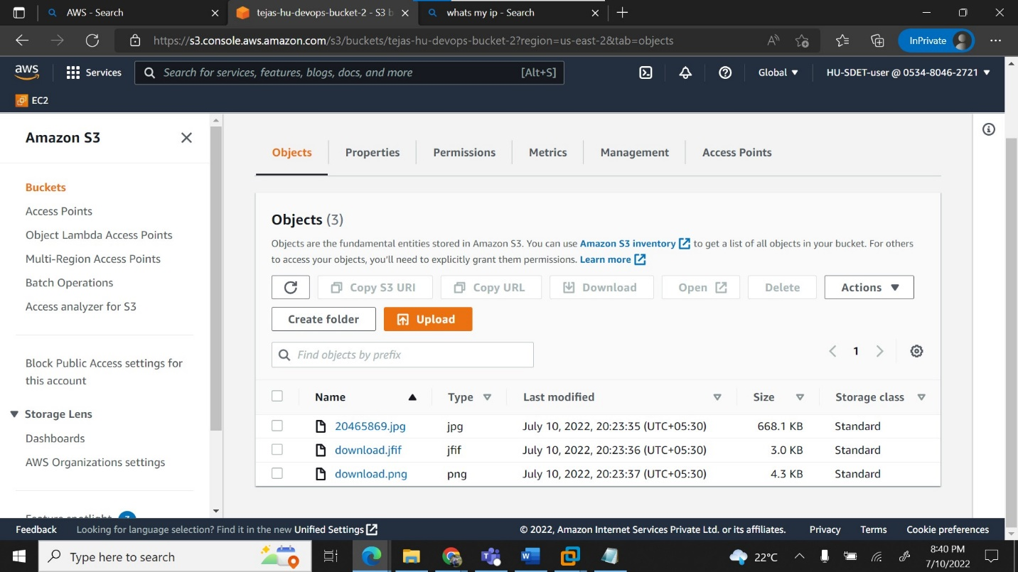

**Q5)** a). Create an AWS EBS volume of 15 GB and attached it to the instance created in Q1)

mount it properly on the location /<-your-name> and put some sample data into the mounting permanent

b). Increase the existing EBS volume size to 20 GB and verify the changes.

6. **Q6)** a) Launch RDS Instance - MySQL - db.m5.large. Do a telnet & check the connection from instance launched in Q1.

7) Create a lambda function and Integrate with Rest API Gateway.

a)Test the code in lambda function test events.

b)And test the get method in API Gateway

